112英語比賽-國小故事組
Acadamic year 112 English Competition - Elementary School Story Group
參賽者:
Good morning, teachers and classmates. I’m number( ). I want to tell you a science experiment.”Walking water science experiment.”
Do you know how to make water walk? Let me show you how to make it. Try this science experiment to make water 'walk'. You can even make rainbow colors!

Before you start，Ask an adult if you can do the experiment.

What you need，three empty glasses, water, food coloring, and some paper towels.

How to do it?
- First put a few drops of yellow food coloring in a glass.
- Then put a few drops of blue food coloring in another glass.
- Next fill the glasses with water.
- Put an empty glass in the middle.
- Fold a paper towel to make a long thin piece.
- Put one end in the yellow water and the other in the empty glass.
- Then fold another paper towel.
- Put one end in the blue water and the other in the empty glass.
- Wait for an hour or two.
- Finally look at the glass in the middle. What can you see?
- And unfortunately, or lucky me today, we have just one minute left, so here is some magic power, see?
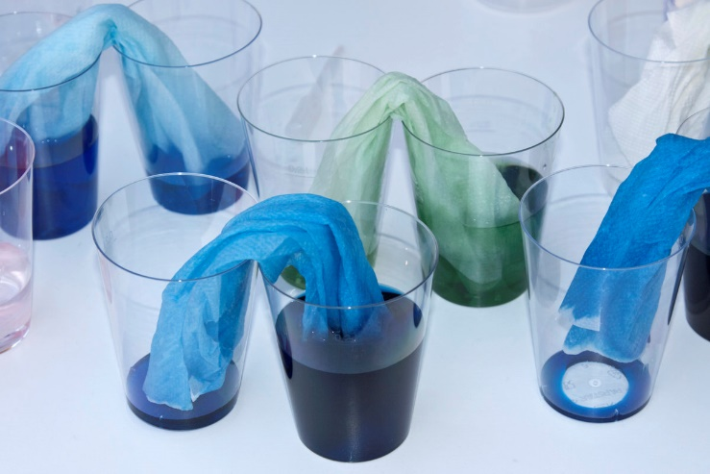

How does it work?
This experiment works because of something called 'capillary action'. Usually water only flows down, because of gravity. But as the spaces between the fibres of the paper towel are so small, the water actually moves up, against gravity!

Did you know? Trees also use capillary action. Water moves up the roots to feed the whole tree!

Now try…
Did you see green water in the middle glass? That's because yellow and blue make green. You can do the experiment using different colours. Try using seven glasses to make a 'rainbow'!

